

APPENDIX 5:
SLA Software Requirements Specifications

Revision History
Date | Version | Description | Author

Table of Contents
1 Introduction 4
1.1 Purpose 4
1.2 Definitions, Acronyms and Abbreviations 4
1.3 References 4
2 Block Templates 4
2.1 Btmp6 - Text-Graphic Block Template 4
2.1.1 Composition 4
2.1.2 New KCEdit functions: 6
3 Other requirements 6
3.1 OR1 - KCEdit allows to customize a common style for specific places 6
3.2 OR3 - KCEdit allows to add all kinds of link in a text/paragraph 6
3.3 OR4 - KCEdit allows to add bookmark in a text/paragraph 6
3.4 OR5 - KCEdit allows SCA users to set the asset type for the package 6
3.5 OR6 - Enable the ‘copy’ and ‘hide’ button for overlay packages 6

SLA Requirements Template Specifications

Introduction

Purpose
This document describes how features work in the system

Definitions, Acronyms and Abbreviations
Acronyms/Abbreviations | Definitions

References
- SLA_Product_Requirements_version1.0.doc

Block Templates

Btmp6 - Text-Graphic Block Template

Composition
This template contains only an ordered-list which in turn contains:
- Block-headers: the headings of all kinds that are pre-defined in the system (h1 to h6). By default, h5 and h6 will look like normal text, but user should be able to modify the styles for them.
- Texts: can have all the bullet formats that are currently supported in html: disc (), square (), circle () or none (without bullet)
- Images: with the max width varying depending on the type of the column:

Column | Max width
50/50 | 340px
1/3 | 160px
2/3 | 525px
  - If a graphic is bigger than the max value, it will be shrunk. If a graphic is smaller than the maximum width, it will appear centered in the column.
  - Graphic should have no height restrictions.
Notice, however, that KCEdit users can still add other elements that are currently supported to add in an ordered-list (i.e. course-link, book-link, dynamic assets,…)
Those elements, when added into this ordered-list, will display like normal link, i.e. book-link, for instance, will only have the title and no image or imprint.
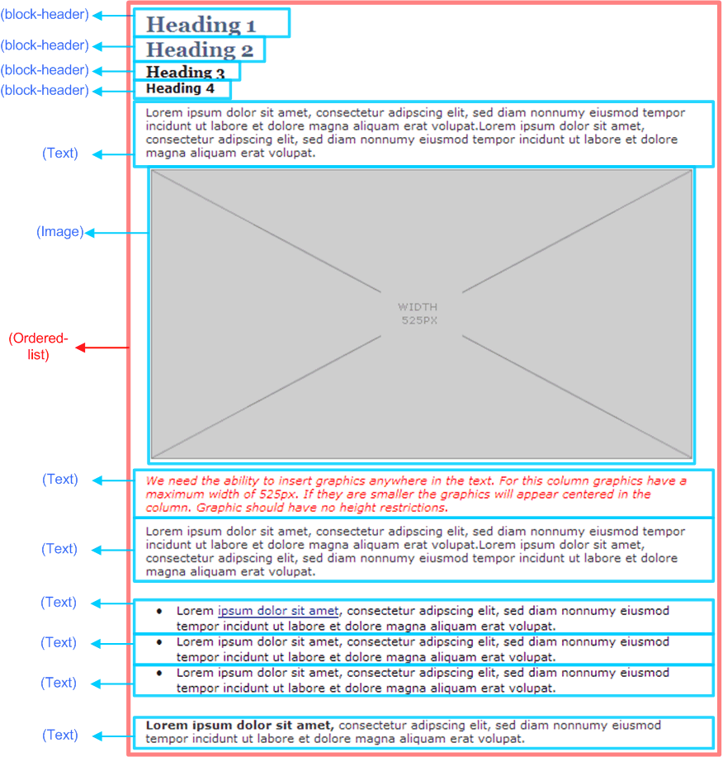

New KCEdit functions:
- Support adding Image into the Ordered-list.
- Support using bullet formats for Text elements.

Other requirements

OR4 - KCEdit allows to add bookmark in a text/paragraph
Inserted through text editor. When user chooses to do so, a list of bookmarks to all the blocks inside that page appears so user can choose from. This will add a js code inside the text.

OR5 - KCEdit allows SCA users to set the asset type for the package
This flag will be kept in content.xml file under a new attribute “asset-type” of <knowledge-center>. This attribute will have the value: ‘_ss_kc’ or ‘_ss_sla’.
On KCEdit GUI, the attribute is displayed as a dropdown list, which contains 2 values: ‘KC’ and ‘SLA’.
In KCEdit, this field should only be seen and edited by SCA but not CCA.

OR6 - Enable the ‘copy’ and ‘hide’ button for overlay packages

